DEFAULT CONSTRAINT

The default constraint lets you define a value that is assigned to a column when the user does not specifically supply a value when a new row is added to the table (using the INSERT statement). A default constraint can be defined on any column except:

- A column with the timestamp data type
- A column with the identity property

The value of the default can be supplied via a constant or a function or it can be null. The default constraint name should use a prefix of DF (indicating this is a default constraint).

Syntax: [CONSTRAINT constraint name]
DEFAULT constant | function | null

Examples:

Default | Constraint Definition
Use the current date as the default for the DateReceived column | Constraint DF_DateReceived Default GetDate()
Use null as the default for the PostalCode column | Constraint DF_PostalCode Default Null
Use 5.90 as the default for the HourlyRate column | Constraint DF_HourlyRate Default 5.90

*** GetDate() is a function, which returns the system date.

A column level definition is used to define a default constraint.

Example:

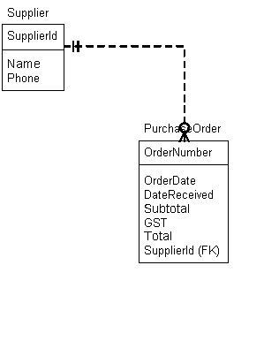

To set a default of the current date for the OrderDate column in the PurchaseOrder table we use the GetDate() function to supply the system date as the default value:

Create Table PurchaseOrder (

OrderNumber int identity (1,1) not null
Constraint PK_PurchaseOrder Primary Key clustered,
OrderDate smalldatetime not null
Constraint DF_OrderDate Default GetDate(),
DateReceived smalldatetime not null,
SupplierId int not null
Constraint FK_PurchaseOrderToSupplier references Supplier (SupplierId),
SubTotal money not null
Constraint CK_SubTotalMustBePositive Check (Subtotal > 0),
GST money not null
Constraint CK_GSTMustBePositive Check (GST > 0),
Total as Subtotal + GST,

Constraint CK_DateReceivedMustBeOnOrAfterOrderDate
Check (DateReceived >= OrderDate)
)
Exercise

Establish 5.0 as the default number of hours per week that an employee will work on a project.

